**Empathy Map** 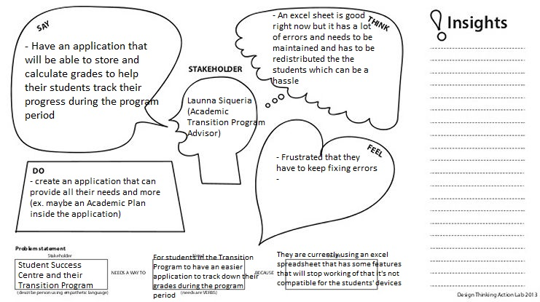

**Function Requirements**

The Grading Calculator must be able to:

* Have users signup and log in
* Store users inputs (assignment grades, grades from previous classes)
* From those stored data be able to calculate the user’s UGPA according the University of Regina standard
* Have those data and calculations saved when the user logs back in so that they don’t have to keep entering their grades
* Have a different section for the Academic Transition Program class
* Be able to also be used by other students not just the ones in the program
* Student can download pages to submit their assignments to their SSW ACT course

**Constraints**

* Users will need to enter their previous grades in order to determine their UGPA and store it in the database.
* Not free to design what we want, we have to constantly meet with the stakeholders for them to approve every step with make.